Karns Pre-K Student Arrival and Dismissal Plan
Starting August 19,2024 to the end of the school year

Starting Monday August 19, 2024, we will be switching to our normal arrival and dismissal plans. We will be continuing with our staggered day schedule for the building to be open at 7:45am until August 21st . Beginning on August 22nd our school doors will open at 7:15am. Our regular school hours of 7:30 -1:30 will begin on August 22,2024. We will be using the right K-2 lane for arrival and dismissal.

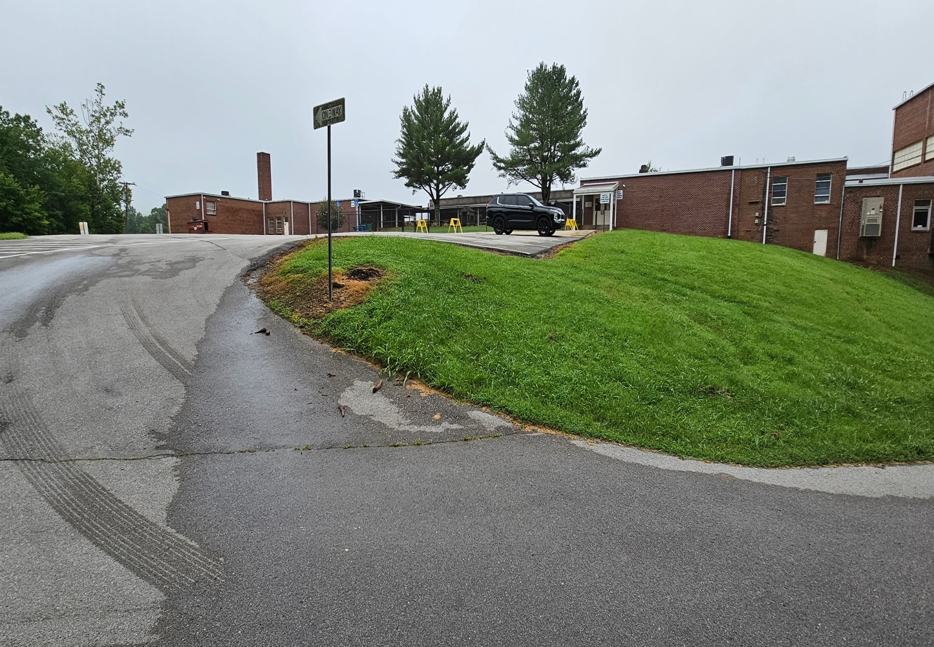
AM/PM- Drop off and pick up line starting point. Line will move up starting at 7:15am. This is the K-2 lane.
Arrival:
AM Doors open at 7:15am. School starts at 7:30am. The tardy bell rings at 7:45am. All students that are tardy must check in through the Karns Pre-K office.

Dismissal:
PM Dismissal starts at 1:30pm. Please do not block bus pick up location in the front parking lot.

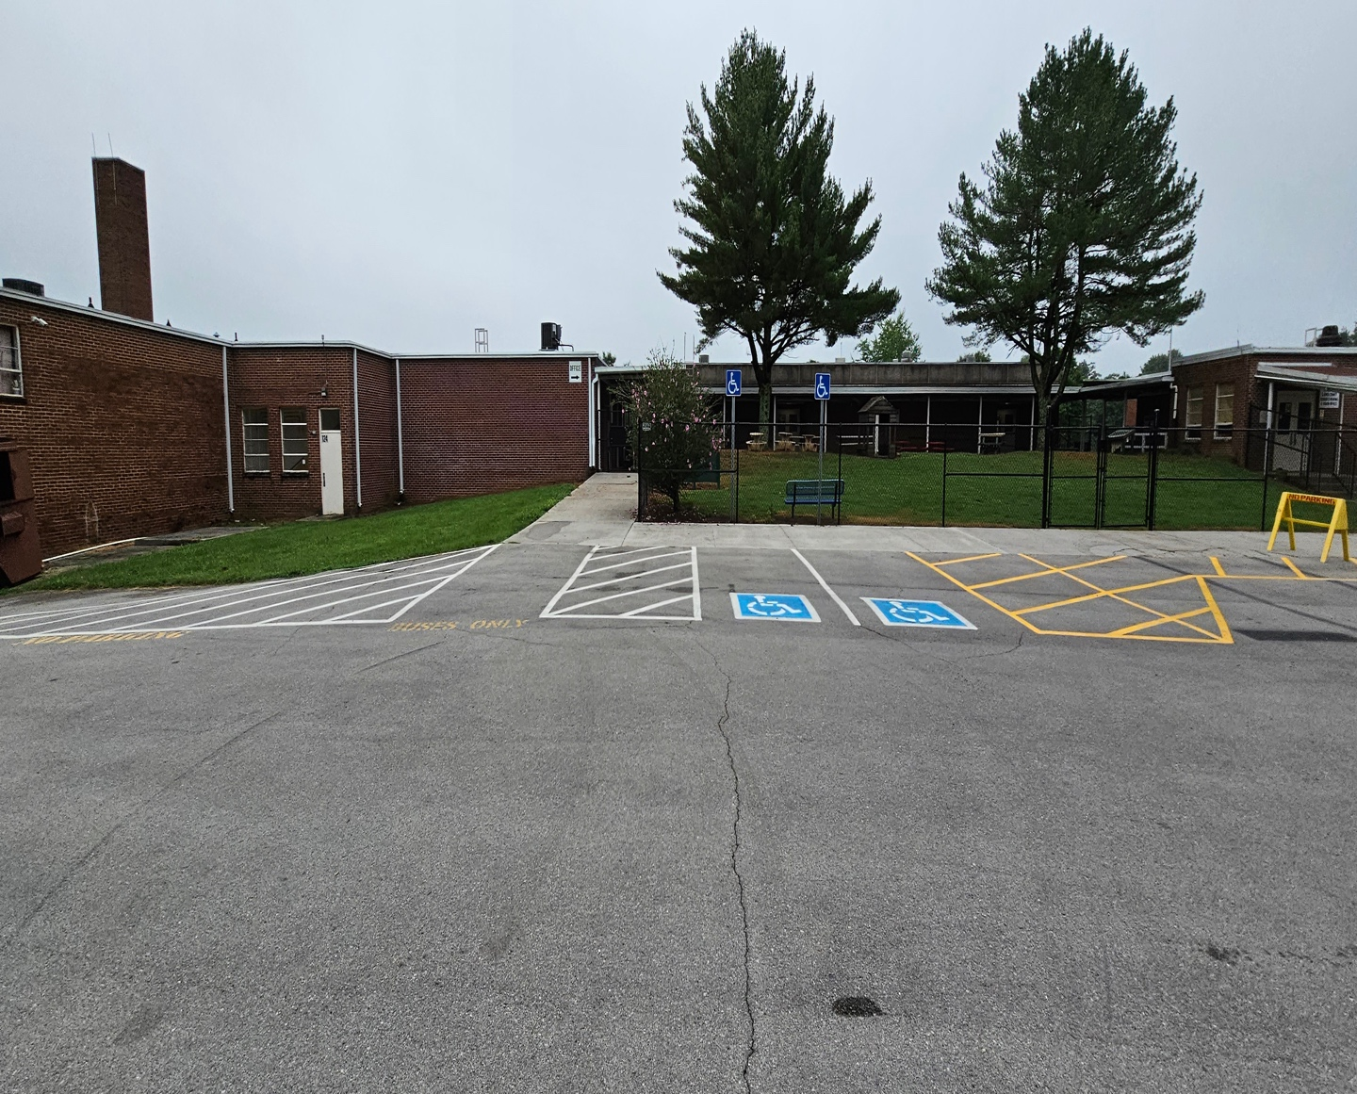
All morning drop offs, and afternoon pick-ups will go through Gate C.

AM/PM Drop off and pick up point. A staff member will be present to sign students in and out. Students are to remain in your vehicle until a staff member checks them in on arrival.

Things to remember: Please have your pickup tag and your ID when picking your student up. Anyone that is picking your child up must be on your child’s pickup list. We will not release any student to a person not on the students pickup list. Staff members are not allowed to buckle students into cars at dismissal.

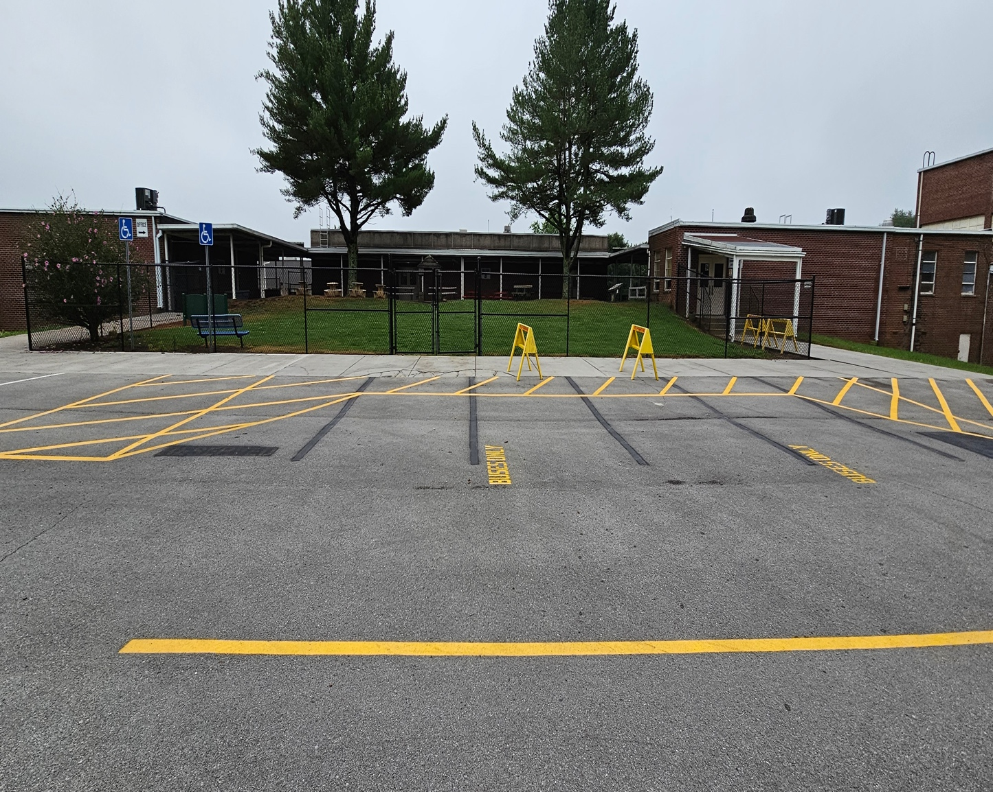
Bus Lane

Please do not block bus lane in the AM/PM. We will que vehicles up in the morning to Gate C when arrival starts at 7:15am.

We will que cars up in the afternoon after our buses leave first.

Thank your patience and adherence to our arrival and dismissal plan.

